# CP 301: DEVELOPMENT ENGINEERING PROJECT

**DESIGN AND DEVELOPMENT OF A QUADRUPEDAL ROBOT**

*Submitted by*

Spandan Seth (2022MEB1334)  
  
Sunny Bharti (2022MEB1335)   
  
Tejasva Jindal (2022MEB1359)

*Supervisor*

**Professor Prabir Sarkar**



**INDIAN INSTITUTE OF TECHNOLOGY ROPAR   
September 2025**

TABLE OF CONTENTS

Contents

CP 301: DEVELOPMENT ENGINEERING PROJECT 1

CHAPTER 1 ABSTRACT 3

CHAPTER 2 INTRODUCTION 4

CHAPTER 2 LITERATURE REVIEW 5

CHAPTER 4 PROBLEM STATEMENT 10

CHAPTER 5 METHODOLOGY 11

CHAPTER 6 RESULTS AND DISCUSSIONS 22

CHAPTER 7 FINDINGS AND CONCLUSIONS 27

CHAPTER 8 REFERENCES 31

# CHAPTER 1 ABSTRACT

The design and development of quadrupedal robots has gained significant attention in recent years due to their ability to traverse terrains and environments that are inaccessible to traditional wheeled and tracked robots. This project, undertaken as part of the CP301 Development Engineering course, focuses on the creation of a quadrupedal robotic platform inspired by animal locomotion. The objective is to engineer a mobile system capable of reliable movement on uneven surfaces while integrating perception and control mechanisms that enable exploratory functionalities. The broader vision is to establish a modular foundation upon which more advanced navigation, sensing, and application-specific systems can be developed in the future.

The work began with a detailed study of the limitations of conventional robotic platforms, followed by an extensive literature review of state-of-the-art quadrupeds including Boston Dynamics’ Spot, Unitree’s Go1, MIT’s Mini-Cheetah, and ETH Zurich’s ANYmal. Drawing insights from these platforms, the project team developed a structured methodology comprising three major phases: kinematic analysis, 3D modeling and design, and visualization and simulation. The kinematic structure of the robot was defined as a 3-DOF serial manipulator for each leg, and inverse kinematics algorithms were implemented to determine feasible joint angles for desired foot positions. To optimize mechanical efficiency, a dual parallelogram linkage system was incorporated in each leg, allowing actuators to be mounted at the top of the leg. This significantly reduced torque requirements and enhanced energy efficiency compared to traditional motor placement strategies.

The robot was modeled in SolidWorks, with design emphasis on lightweight yet robust components. A body frame of aluminum extrusion was selected for strength and modularity, while PLA components were used for leg links to ensure ease of prototyping. The CAD model was converted into URDF format and successfully visualized in RViz within the ROS environment. This enabled real-time simulation, validation of the kinematic chain, and testing of different gait patterns. Among the gait strategies considered—crawl, trot, and gallop—the trot gait was selected as the most suitable compromise between stability, speed, and power efficiency.

The control and electrical architecture integrates a Raspberry Pi 4 as the central processing unit for high-level motion planning, supported by an ESP32 microcontroller and PCA9685 drivers for servo actuation. A USB webcam serves as the initial perception system, providing visual feedback for exploratory tasks. Planned extensions include integration of LiDAR, IMU, and other advanced sensors to enable autonomous navigation and obstacle avoidance.

Preliminary results confirm the feasibility of the design, with validation achieved through RViz simulations and kinematic calculations. The project highlights the importance of actuator placement, linkage mechanisms, and modular system design in achieving stable and efficient quadrupedal locomotion. Potential applications extend across agriculture, search-and-rescue, environmental monitoring, and industrial inspection, where adaptability to challenging environments is essential. Overall, this work establishes not only a functional prototype framework but also a scalable platform that can be expanded to meet diverse societal and industrial needs in the future.

# CHAPTER 2 INTRODUCTION

**General Context**

In an increasingly automated world, mobile robotics has become essential for addressing challenges in environments that are hazardous, inaccessible, or repetitive for human workers. While wheeled and tracked robots excel on flat surfaces, many real-world scenarios require navigation through uneven terrain, stairs, debris, and confined spaces where traditional mobility solutions fall short. Quadrupedal robots, inspired by natural animal locomotion, offer a promising solution by combining the stability of multiple contact points with the adaptability needed for complex terrains.

**Importance and Relevance**

The development of robot dogs addresses critical needs across multiple sectors. Industries require safer inspection methods for hazardous environments such as chemical plants, nuclear facilities, and disaster zones. Emergency services need reliable platforms for search and rescue operations in collapsed structures or dangerous terrain. Military and security applications demand reconnaissance capabilities in challenging environments where human presence is risky or impractical. As these needs continue to grow, the ability to develop cost-effective, reliable quadrupedal robots becomes increasingly valuable for society's safety and efficiency.

**Motivation for Project Selection**

The selection of robot dog development as our project topic stems from the unique engineering challenges it presents and its practical relevance to modern technological needs. This project offers an opportunity to integrate multiple engineering disciplines including mechanical design, control systems, sensors, and artificial intelligence in a single cohesive platform. The complexity of achieving stable dynamic locomotion while maintaining environmental awareness provides an excellent learning experience in advanced robotics. Additionally, the growing market demand for such platforms makes this project both academically enriching and professionally relevant.

**Project Objectives**

The primary objectives of this robot dog development project are:

* **Design and fabricate** a quadrupedal robot platform capable of stable locomotion on various terrains
* **Develop control algorithms** for dynamic gait generation and balance maintenance during movement
* **Integrate sensor systems** for environmental perception and obstacle detection
* **Implement autonomous navigation** capabilities for basic path planning and execution
* **Create a user interface** for remote monitoring and control of the robot's operations
* **Evaluate performance** through systematic testing of mobility, stability, and task execution capabilities
* **Document the development process** to contribute insights for future quadrupedal robotics projects
* **Analyze cost-effectiveness** and scalability of the developed solution for potential commercial applications

# CHAPTER 2 LITERATURE REVIEW

The development of quadrupedal robots has undergone significant evolution over the past two decades, transitioning from laboratory prototypes to commercially viable platforms. The field gained substantial momentum with early pioneering work that established fundamental principles of dynamic locomotion and balance control in legged systems. These robots are motivated by the ability of animals, particularly dogs, horses, and cheetahs, to move efficiently across rough terrain, adapt to unexpected disturbances, and execute a wide range of dynamic gaits.

**2.1 Boston Dynamics BigDog and Spot**

Boston Dynamics revolutionized the field with the BigDog project, which demonstrated unprecedented mobility and load-carrying capabilities on rough terrain. The BigDog robot, weighing approximately 110 kg, utilized hydraulic actuators powered by a two-stroke gasoline engine, enabling it to carry payloads up to 150 kg across challenging terrains. However, the system's high power requirements, significant noise production, and maintenance complexity highlighted the limitations of hydraulic actuation for practical applications.

Building upon BigDog's foundation, Boston Dynamics developed Spot, a more refined platform that addressed many of the earlier system's limitations. Spot represents a significant advancement in commercial quadrupedal robotics, featuring electric actuation, reduced noise levels, and enhanced environmental awareness through advanced sensor integration.

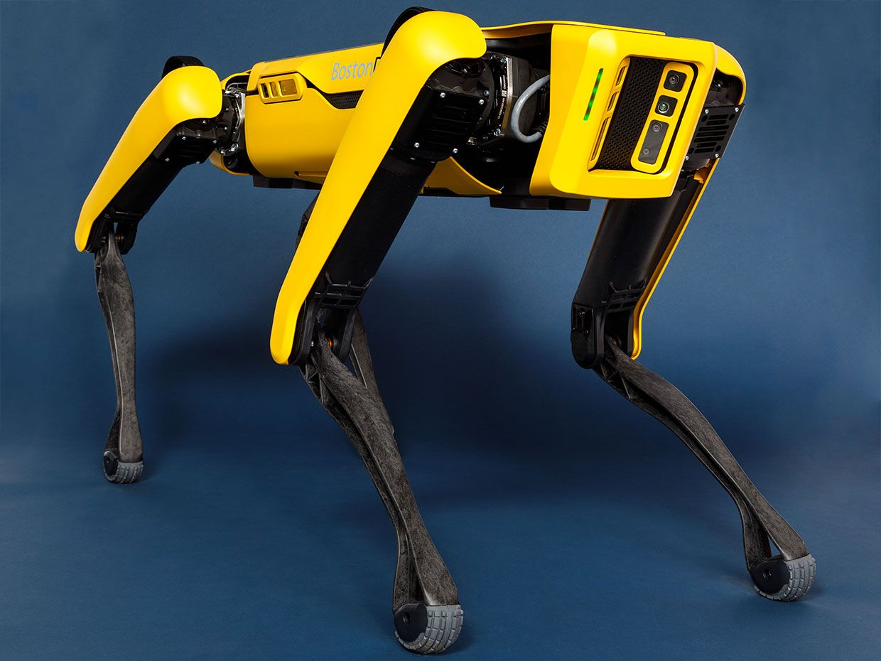

Fig- Boston Dynamics Spot Robot

**2.2 Unitree Robotics Platforms**

Unitree Robotics has emerged as a significant player in the affordable quadrupedal robot market, developing platforms such as the A1 and Go1 series. These robots focus on cost-effectiveness while maintaining robust locomotion capabilities, typically featuring 12 degrees of freedom with custom servo actuators and demonstrating capabilities including autonomous navigation, obstacle avoidance, and various gait patterns.

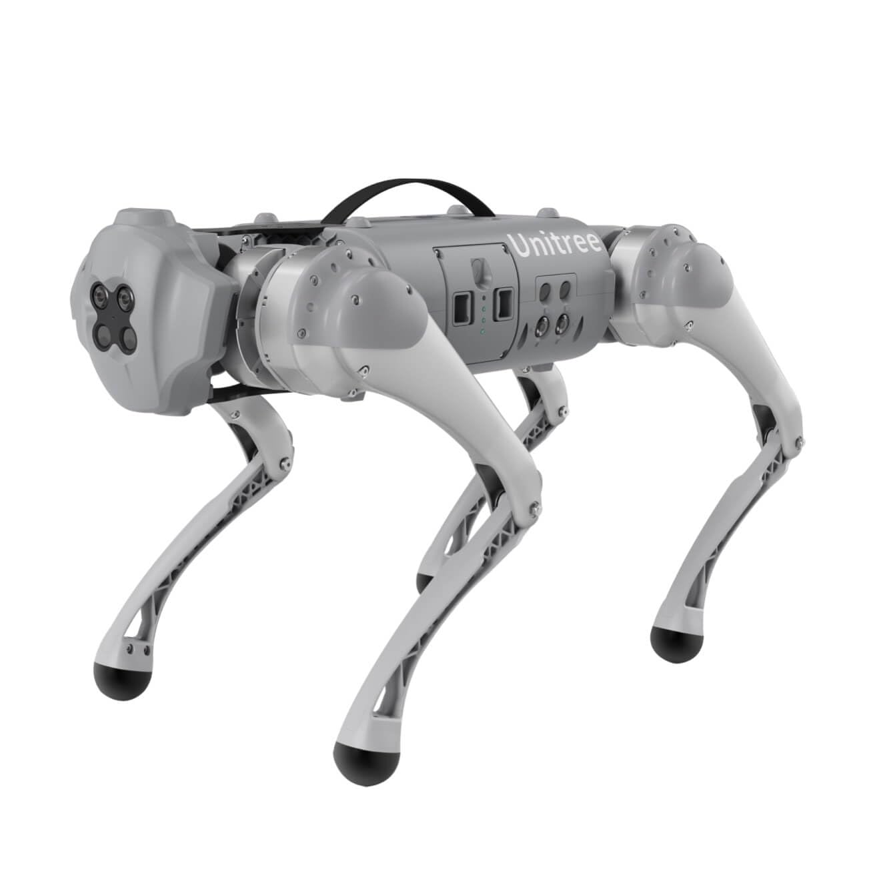

Fig- Unitree Go1 Robot

**2.3. Academic Research Platforms**

**2.3.1 MIT Mini-Cheetah and Cheetah 3**

The MIT Mini-Cheetah represents a significant breakthrough in dynamic quadrupedal locomotion. Weighing only 9 kg, the platform achieves remarkable agility through custom high-power modular electric actuators. Each actuator incorporates a brushless DC motor with planetary gears, encoder, and controller, all communicating via a single CAN bus. The Mini-Cheetah's key innovation lies in its ability to perform dynamic maneuvers including backflips.

The MIT Cheetah 3, developed by the MIT Biomimetic Robotics Lab, represents high-performance quadrupedal robotics engineered for robust, high-speed, and dynamic locomotion. It employs proprioceptive electric actuators with custom high-torque motors coupled with planetary gear reductions, enabling behaviors such as running, leaping, and blind stair climbing. The robot achieves a cost of transport as low as 0.45 during trotting and integrates model predictive control (MPC) to handle hybrid dynamics of legged locomotion.



Fig- MIT Cheetah

**2.3.2 ETH Zurich ANYmal**

The ANYmal platform represents advanced research in robust quadrupedal locomotion. Weighing 30 kg with a height of 0.5 m, ANYmal has demonstrated exceptional performance in real-world applications including industrial inspection and search-and-rescue operations. The platform's series elastic actuators and sophisticated control algorithms enable robust performance against impulsive loads during running and jumping.

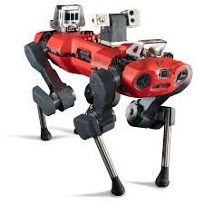

Fig- ANYMal Robot

**2.3.3 XDog: Modular Design Approach**

XDog, developed at the National University of Defense Technology in China, represents an important step in modular quadruped robot design. Its primary innovation lies in its mechanical configuration, particularly the use of coplanar hip joints offset from the body, which increases the range of motion and allows the robot to squat fully. The bilateral modular leg design allows each leg to be reconfigured for different orientations, enabling researchers to test various quadrupedal configurations.



XDog Robot

**2.4 Open-Source Development Platforms**

**2.4.1 HyperDog Platform**

The HyperDog platform represents a significant contribution to open-source quadrupedal robotics. This 12-DOF platform, built entirely from 3D-printed parts and carbon fiber, demonstrates that effective quadrupedal robots can be developed using accessible manufacturing techniques. Key specifications include dimensions of 300mm × 175mm × 240mm, weight of 5 kg with 2 kg payload capability, and operation time of ~50 minutes using an 8.4V Li-Ion battery system.



Fig- Hyperdog Robot

**2.4.2 Stanford Platforms**

Stanford Doggo proposed a torque-controlled legged platform focusing on educational applications, while Stanford Pupper was designed specifically for educational purposes and hobbyist development. The Pupper platform features completely 3D-printed frame construction with standard servo motors, making it highly accessible for students and researchers with limited budgets.

**2.5 Technical Evolution and Design Approaches**

**2.5.1 Actuation Technologies**

The evolution from hydraulic to electric actuation represents a significant trend in quadrupedal robotics. While hydraulic systems offer high power density, they suffer from noise, maintenance complexity, and energy efficiency issues. Electric motor-based systems provide quieter operation, reduced maintenance requirements, and better integration with modern control electronics, despite lower torque density.

**2.5.2 Control Systems and Software Architectures**

The adoption of Robot Operating System (ROS) frameworks has standardized software development in quadrupedal robotics. Modern platforms implement multiple gait patterns including walking, trotting, and running gaits, with real-time adaptation based on terrain conditions. Research has evolved from static stability approaches to dynamic locomotion algorithms incorporating model predictive control and neural-inspired strategies.

**2.5.3 Mechanical Design Trends**

Modern quadrupedal robots emphasize lightweight construction and optimal mass distribution. The trend toward 3D-printed components enables rapid prototyping and customization while maintaining structural integrity. Carbon fiber integration provides the necessary strength-to-weight ratio for dynamic applications, while compliance mechanisms such as spring dampers and series elastic actuators improve terrain adaptability.

**2.6. Comparative Analysis and Future Directions**

The reviewed platforms illustrate different yet complementary approaches to quadruped design:

* **XDog** emphasizes mechanical modularity and mass distribution for experimental versatility
* **MIT Cheetah 3** demonstrates engineering optimization combining electric actuators and predictive control
* **HyperDog** addresses accessibility through open-source design and affordable manufacturing

Despite significant advances, several challenges remain including energy efficiency, terrain adaptability in highly irregular environments, cost accessibility for widespread research adoption, and standardization of interfaces and evaluation metrics. The trend toward open-source platforms and accessible manufacturing techniques continues to democratize quadrupedal robotics research, while commercial platforms push the boundaries of performance and real-world deployment capabilities.

# CHAPTER 4 PROBLEM STATEMENT

Conventional mobile robots, particularly those with wheeled or tracked mechanisms, face significant challenges in navigating uneven, rugged, or unstructured terrains. These limitations restrict their usability in exploration, inspection, and agricultural applications, where adaptability to irregular ground surfaces is crucial. There is a growing need for robotic platforms capable of operating in such environments, providing reliable locomotion and perception while maintaining flexibility for future extensions.

Significance of the Problem

The ability to deploy robots in regions inaccessible to traditional wheeled or tracked robots holds immense practical significance. Such robots can reduce human risk in hazardous environments, assist in agricultural productivity, and expand exploration capabilities in both structured and unstructured terrains. Quadruped robots, with their biological inspiration, are inherently more capable of adapting to irregular surfaces, confined spaces, and obstacles. Integrating perception systems such as cameras and sensors further enhances their utility by enabling exploration, monitoring, and navigation tasks. This makes quadruped robots an ideal solution for a wide range of real-world applications, from agricultural support and environmental monitoring to surveillance and industrial inspection.

Specific Aim / Research Question

The primary aim of this project is to design and develop a quadruped robotic platform with the following objectives:

1. Mechanical Framework Development: Construct a robust quadruped structure capable of stable and reliable locomotion on varied terrains.
2. Locomotion Implementation: Develop and test stable walking patterns for effective mobility across uneven surfaces.
3. Integration of Perception Systems: Incorporate a USB webcam as the initial onboard sensor to provide real-time visual feedback, enabling basic exploration and navigation.
4. Scalability for Future Applications: Establish a modular design framework that allows for the integration of advanced sensors such as 2D LiDAR, ultrasonic rangefinders, and additional tools for autonomous navigation, obstacle avoidance, and domain-specific tasks.

Long-Term Vision

While the immediate focus is on building a functional quadruped robot with exploratory abilities, the broader vision is to evolve the platform into a versatile, multifunctional robotic system. Potential applications include:

* Agriculture: Crop row following, yield estimation using vision, payload transportation, and livestock monitoring.
* Environmental and Field Exploration: Terrain mapping, ecological data collection, and perimeter inspection.
* Research and Industrial Applications: Serving as a reconfigurable platform for academic projects, industrial inspection tasks, and testing novel locomotion or sensing algorithms.

Through this work, the project aims not only to demonstrate the feasibility of quadrupedal locomotion and basic perception but also to lay the foundation for a modular robotic system capable of addressing diverse challenges in agriculture, exploration, and beyond.

# 

# CHAPTER 5 METHODOLOGY

**5.1 Problem Approach**

The development of the quadruped robot dog follows a systematic engineering approach divided into three main phases: Design and Modeling, Kinematic Analysis, and Visualization and Simulation. This methodology ensures a comprehensive understanding of the mechanical system before proceeding to physical implementation.

The project adopts a bottom-up approach, starting with fundamental kinematic calculations, progressing through detailed 3D modeling, and culminating in visualization and simulation to validate design decisions.

**5.2 Tools and Software Used**

5.2.1 Design and Modeling Tools

* SolidWorks: Primary CAD software for 3D modeling and mechanical design
* SolidWorks Simulation: For initial stress analysis and motion studies

5.2.2 Simulation and Visualization Tools

* RViz (ROS Visualization): 3D visualization environment for robot state display
* ROS (Robot Operating System): Framework for robot software development
* URDF (Unified Robot Description Format): XML format for describing robot geometry and kinematics

**5.3 Step-by-Step Process**

5.3.1 Phase 1: Kinematic Analysis and Mathematical Modeling

Step 1: Kinematic Chain Definition

* Defined the kinematic structure of each leg as a 3-DOF serial manipulator
* Identified joint types: hip abduction/adduction, hip flexion/extension, knee flexion/extension

Step 2: Inverse Kinematics Solution

* Implemented geometric approach for closed-form solution
* Developed algorithm to calculate joint angles from desired foot position
* Applied workspace constraints and joint limits

5.32 Phase 2: 3D Modeling and Design (80% Complete)

Step 3: Component Design

* Body Frame: Designed main chassis with dimensions 440mm × 220mm × 120mm
* Hip Joints: Created hip mechanisms with servo motor mounts
* Motor Placement Strategy: Both hip and knee actuators positioned at the top of each leg to minimize the load on individual motors. This configuration prevents motors from having to lift the weight of other motors in the kinematic chain, thereby improving power efficiency and reducing torque requirements.
* Upper Legs: Designed femur links with length 200mm
* Lower Legs: Developed tibia/fibula assembly with extended length to accommodate linkage mechanism
* Parallelogram Linkage Mechanism: Instead of directly integrating motors into the upper link, implemented two parallelogram linkage mechanisms per leg. This design required extension of the lower leg to provide connection points for the connecting rods, ensuring proper force transmission while maintaining motor positioning at the leg's top.
* Feet: Designed contact points with shock absorption consideration

Step 5: Assembly Integration

* Assembled individual components into complete quadruped structure
* Ensured proper joint alignment and mechanical clearances
* Verified assembly constraints and degrees of freedom

5.3.3 Phase 3: Visualization and Simulation Setup

Step 6: URDF Model Creation

* Converted SolidWorks model to URDF format
* Defined joint properties: limits, damping, friction coefficients
* Specified inertial properties for each link
* Configured visual and collision geometries

Step 8: RViz Integration and Visualization

* Imported URDF model into RViz environment
* Configured joint state publisher for manual joint control
* Set up coordinate frame visualization for all joints and links
* Implemented real-time kinematic visualization showing leg movements
* Successfully visualized the complete quadruped robot model with proper joint articulation
* Verified visual representation matches SolidWorks design specifications

Step 9: Simulation Development (In Progress)

* Currently developing dynamic simulation capabilities
* Implementing gait pattern generation algorithms
* Setting up physics-based simulation environment
* Integration of control algorithms with visualization system
* Testing of various locomotion strategies and stability analysis

5.4 Key Assumptions and Constraints

5.4.1 Design Assumptions

* Rigid body assumption for all links (no structural deformation)
* Ideal joint behavior with no backlash or friction losses
* Uniform mass distribution within each link
* Ground contact modeled as point contact at foot location

5.4.2 Design Constraints

* Joint angle limits based on servo motor specifications:
  + Hip abduction: ±45°
  + Hip flexion: ±90°
  + Knee flexion: 0° to 135°
* Maximum leg extension: 350mm (accounting for extended lower leg design)
* Parallelogram linkage geometric constraints for proper force transmission
* Motor placement constraints requiring all actuators at leg top section

5.4.3 Simulation Constraints

* Static analysis only (no dynamic effects considered at this stage)
* Perfect sensor feedback assumed
* No consideration of actuator dynamics or control delays
* Ideal power supply (no voltage drop effects)

5.5 Current Progress Status

Completed Tasks (50% overall progress):

* Complete kinematic analysis and inverse kinematics solution
* Major component design and modeling in SolidWorks with parallelogram linkage integration
* URDF model creation and successful RViz visualization
* Motor placement optimization and linkage mechanism design
* Basic visualization and joint control implementation

In Progress Tasks:

* Dynamic simulation development and physics integration
* Advanced gait planning and control algorithms
* Stability analysis and optimization

Remaining Tasks (50%):

* Final assembly refinement and optimization
* Complete dynamic simulation and testing
* Control system integration and validation
* Physical prototype manufacturing preparation

5.6 Electrical System Design

The electrical architecture of the robot dog follows a distributed control approach with centralized processing. Below is the electrical system flowchart showing the interconnection of major components:

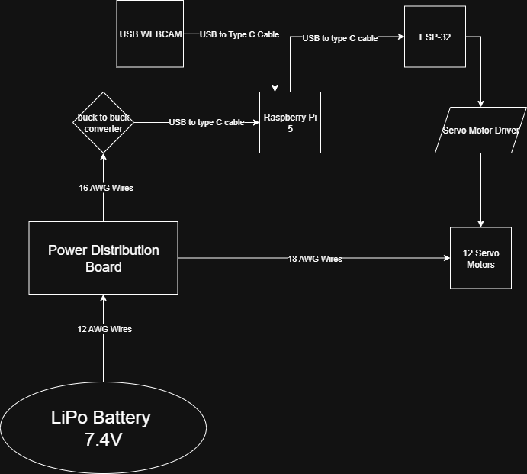

Figure : Electrical System Architecture and Component Integration

5.6.1 Key Electrical Components

* Raspberry Pi 4: Central processing unit for coordinate computation and control
* Servo Motor Driver: Individual servo control circuits for each of the 12 actuators (3 per leg × 4 legs)
* Power Distribution: Regulated power supply system for motors and electronics
* Sensor Integration: IMU and USB Webcam
* Communication Interface: Serial communication protocols for real-time control

5.7 Mathematical Calculations Documentation

The inverse kinematics calculations form the core of the robot's motion planning system. The detailed mathematical derivations and computational results are shown below:

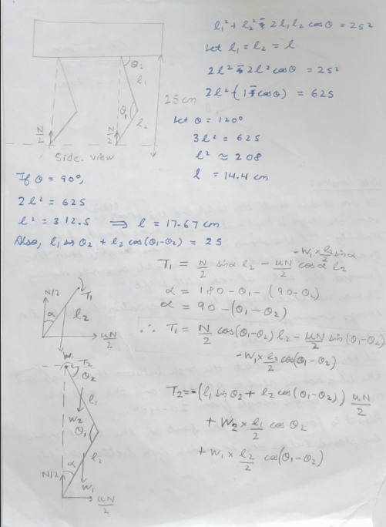

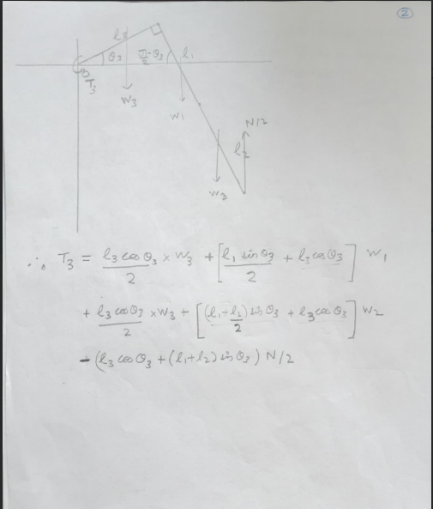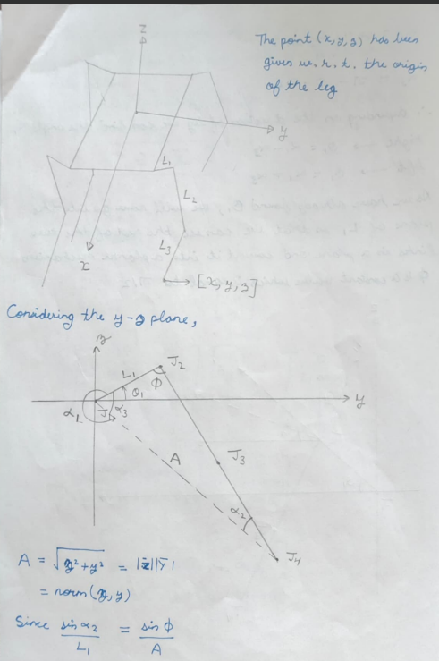

**

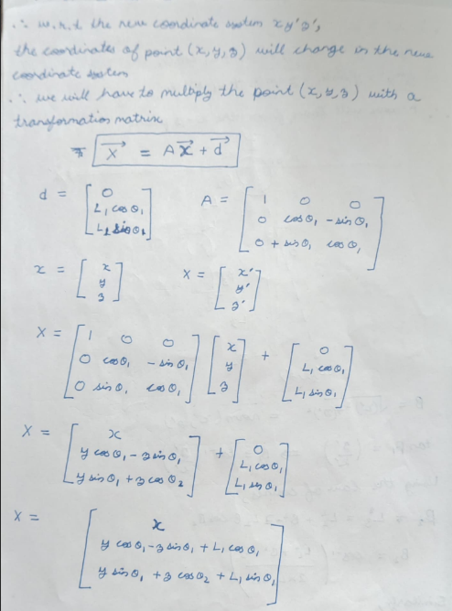

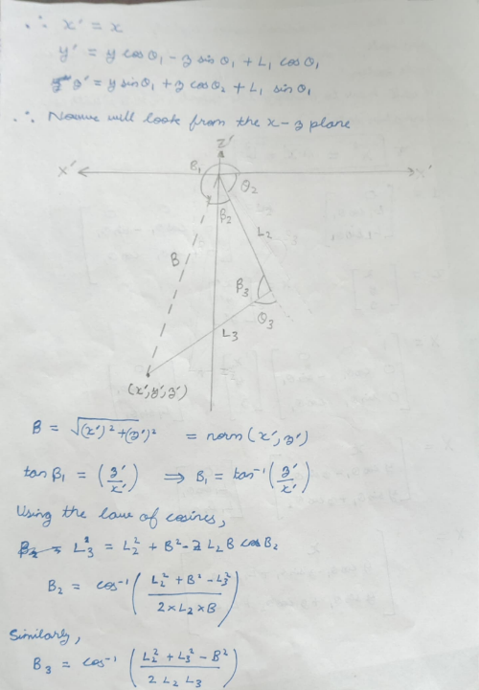

**

# CHAPTER 6 RESULTS AND DISCUSSIONS

**6.1 Final Assembly Results**

The quadruped robot dog design has been successfully completed to 80% with all major components designed and integrated. The final assembly demonstrates a robust mechanical structure optimized for efficient locomotion.

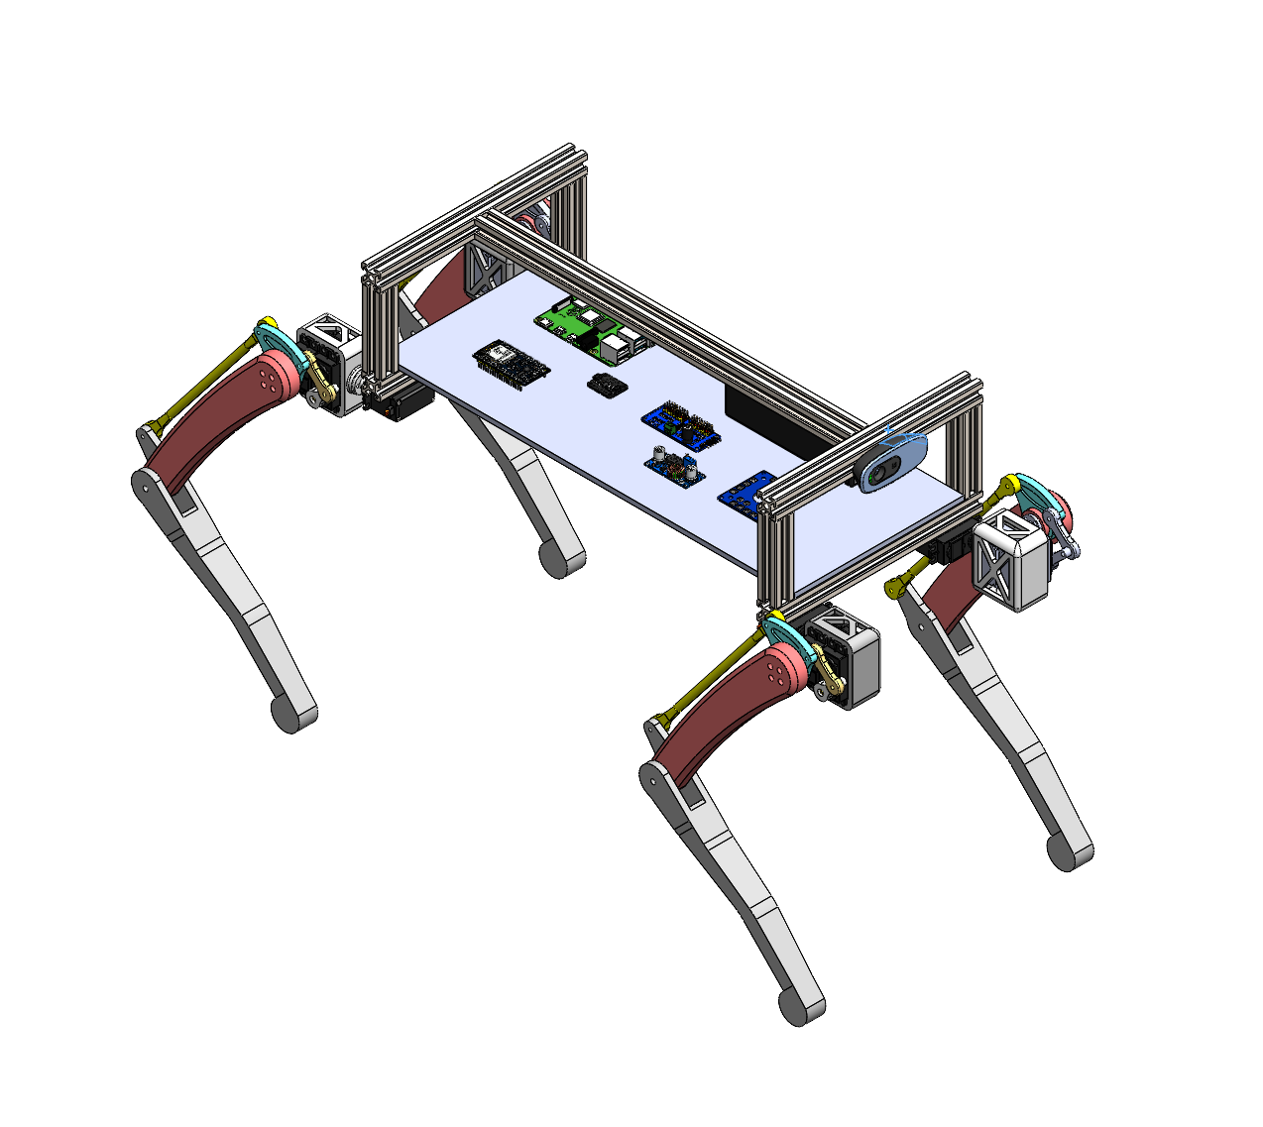

*Figure 6.1: Complete Robot Dog Assembly - Isometric View*

**6.1.1 Individual Component Analysis**

The robot dog assembly consists of several critical components, each designed with specific functional requirements:

**6.1.1.1 Main Body Frame**

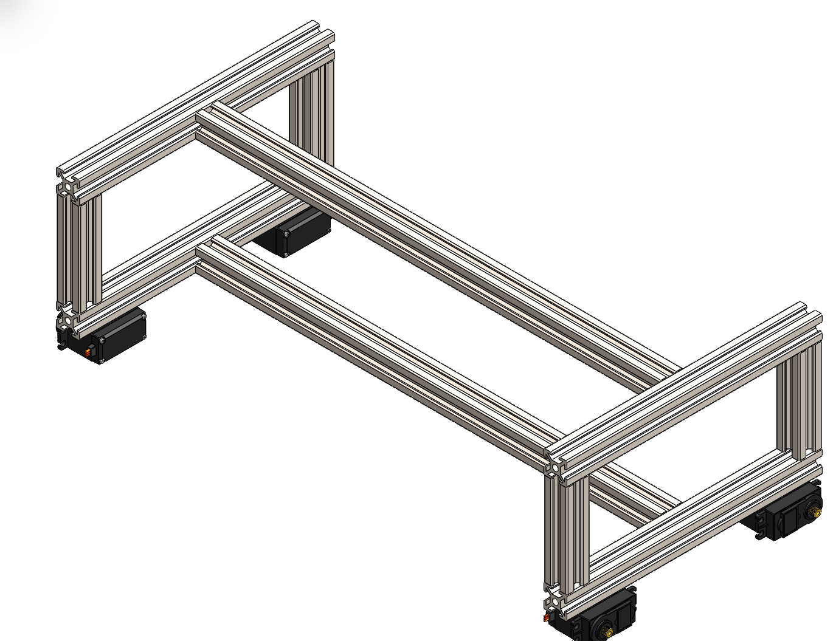

*Figure 6.2: Main Body Frame Assembly*

The central chassis provides the structural foundation for the entire robot. Key features include:

* Dimensions: 400mm × 200mm × 80mm providing optimal weight distribution
* Material selection ensures adequate strength-to-weight ratio
* Mounting points strategically positioned for motor assemblies
* The chassis is made up of Aluminium extrusion on which the hip servo motors are connected

**6.1.1.2 Leg Assembly with Parallelogram Linkage**

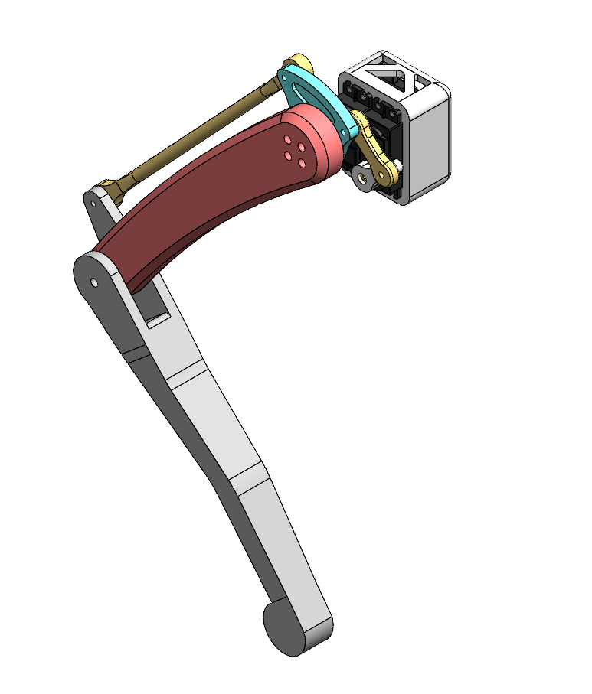

*Figure 6.3: Individual Leg Assembly Showing Parallelogram Linkage Mechanism*

Each leg incorporates the innovative parallelogram linkage design:

* Motor positioning at leg top reduces overall system inertia
* Parallelogram mechanism ensures efficient force transmission
* Mechanism is built in such a way that the mechanical advantage of the links are 1
* Extended lower leg accommodates connecting rod attachment points ensuring a parallelogram linkage
* Three degrees of freedom per leg (hip abduction/adduction, hip flexion/extension, knee flexion/extension)
* The links are made up of PLA

**6.1.1.3 Hip Joint Mechanism**

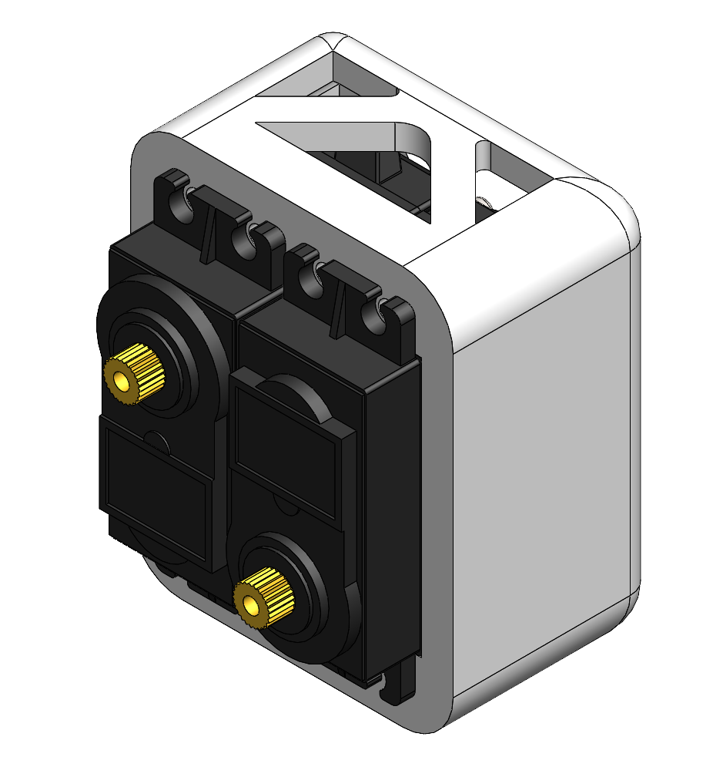

*Figure 6.4: Hip Joint Assembly with Dual Motor Configuration*

The hip joint design features:

* A motor mounting bracket is created in such a way that the both the servo motors are incorporated
* The motors are placed in such a way that the parallelogram linkage in maintained
* Motor mounting brackets designed for easy maintenance
* [Add your specific details here about bearing types, motor specifications, torque ratings, etc.]

**6.2 Model Validation in Rviz**

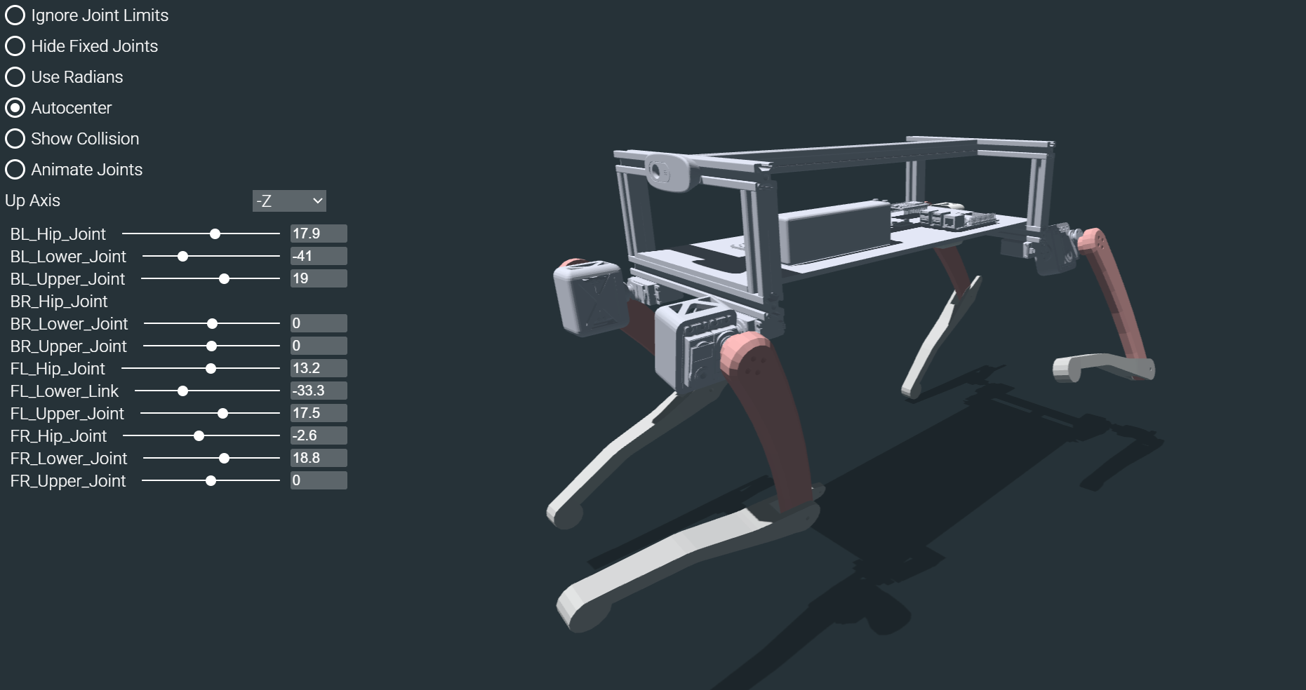

*Figure 7.11: RViz Model Validation - Various Poses and Configurations*

Validation results demonstrate:

* Geometric accuracy between CAD model and URDF representation
* Proper joint range of motion within specified limits
* Correct kinematic chain behavior during articulation
* No model artifacts or visualization errors observed

# CHAPTER 7 FINDINGS AND CONCLUSIONS

**7**.1 Mechanical Design Findings

The development of the quadruped robot dog has yielded several significant findings regarding optimal design strategies for legged robotics:

Positioning both hip and knee actuators at the top of each leg significantly reduces the torque requirements on individual motors This configuration eliminates the need for motors to lift the weight of other motors in the kinematic chain Power efficiency improvements are substantial compared to traditional distributed motor placement

Parallelogram Linkage Mechanism Advantages:

The dual parallelogram linkage design provides superior force transmission compared to direct motor integration Extended lower leg design successfully accommodates connecting rod attachment points Maintains consistent leg geometry throughout the full range of motion Offers improved structural stability during dynamic movements

7.2 Control System Architecture Findings

The electrical and control system design has been optimized for efficient real-time operation:

* Raspberry Pi 4 Model B - Main Controller:
  + Selected as the primary computational unit for all high-level processing tasks
  + Handles inverse kinematics calculations in real-time
  + Performs gait generation and motion planning algorithms
  + Controls gait selection and locomotion pattern switching
  + Sufficient computational power for complex mathematical operations required for quadruped control

* ESP32 Microcontroller - Motor Interface:
  + Serves as the dedicated interface between the main controller and servo motor drivers
  + Receives joint angle commands from Raspberry Pi via Micro-ROS
  + Converts high-level commands to precise servo control signals
  + Provides real-time motor control with minimal latency
  + Ensures reliable communication protocol for 12-servo coordination

* PCA9685 Servo Motor Driver:
  + 16-channel PWM driver selected for comprehensive servo control
  + Controls all 12 servo motors (3 per leg × 4 legs) with 4 channels remaining for future expansion
  + Provides precise PWM signal generation for accurate joint positioning
  + I2C communication protocol enables efficient data transfer from ESP32
  + Built-in oscillator ensures consistent timing for servo control
* Buck-to-Buck Converter - Power Regulation:
  + 5A Buck-to-Buck converter integrated for Raspberry Pi 4 power supply
  + Steps down 7.4V LiPo battery voltage to 5V required for Raspberry Pi operation
  + High current capacity (5A) ensures stable power delivery under computational load
  + Prevents voltage fluctuations that could affect processing performance
  + Isolated power rail protects sensitive computing components from motor noise
* IMU (Inertial Measurement Unit) - Feedback System:
  + Integrated IMU provides essential feedback for balance and orientation control
  + Real-time measurement of acceleration, angular velocity, and magnetic field
  + Critical for maintaining stability during dynamic locomotion
  + Enables closed-loop control for gait correction and terrain adaptation
  + Data fusion algorithms in Raspberry Pi process IMU feedback for stability control
  + Essential component for autonomous navigation and obstacle avoidance

7.3 Mechanical Design Implementation Findings

* SolidWorks Design Achievements:
  + Target height of 45 centimeters successfully achieved through optimized design
  + Link lengths designed between 20-25 centimeters for optimal workspace coverage
  + Mechanical advantage maintained at unity (1:1) throughout the kinematic chain
  + This ensures efficient force transmission without power multiplication losses
  + Material Selection - Aluminum Extrusion:
  + Aluminum extrusion bars selected for structural components due to superior strength-to-weight ratio
  + Material choice supports high payload capacity requirements
  + Provides necessary structural rigidity for dynamic locomotion
  + Enables modular assembly and easy maintenance access
* Payload Capacity Analysis:
  + Payload capacity directly correlated with servo motor specifications
  + 40 kg-cm torque motors provide adequate payload handling for current design
  + Scalable design allows for higher torque motors to increase payload capacity
  + System designed to support additional sensors and equipment mounting

7.4 Locomotion Strategy Findings

Gait Pattern Analysis: Through comprehensive analysis of quadruped locomotion, three primary gait patterns were evaluated:

* Crawl Gait:
  + Single-foot lifting mechanism provides maximum static stability
  + Requires extensive IMU feedback for balance control
  + Slowest locomotion speed but highest stability margin
  + High computational requirements for real-time balance control
  + Suitable for rough terrain navigation but not selected for initial implementation

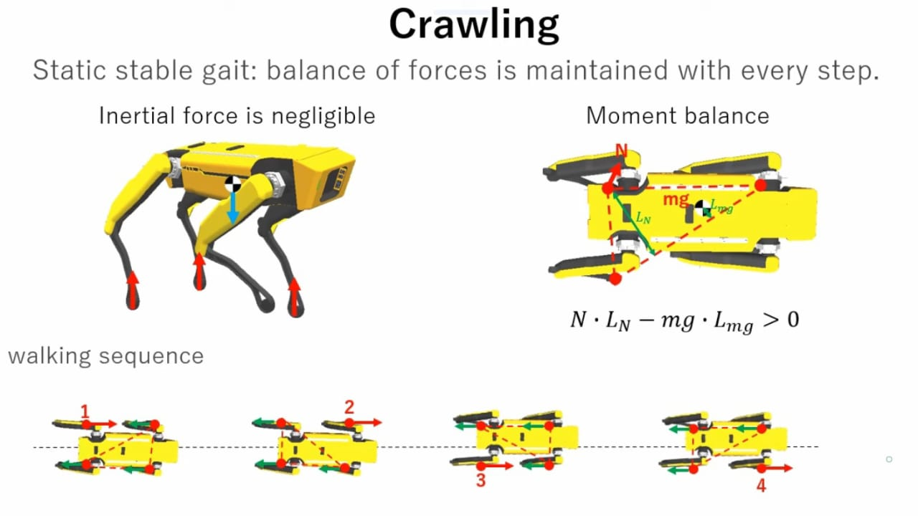

Figure – Crawl Mechanism

* Trot Gait (Selected for Implementation):
  + Diagonal leg pairing provides optimal balance between speed and stability
  + Dynamically stable configuration reduces dependency on complex feedback systems
  + Moderate power consumption suitable for battery operation
  + Proven effectiveness in biological and robotic quadrupeds
  + Selected as primary locomotion method for the project

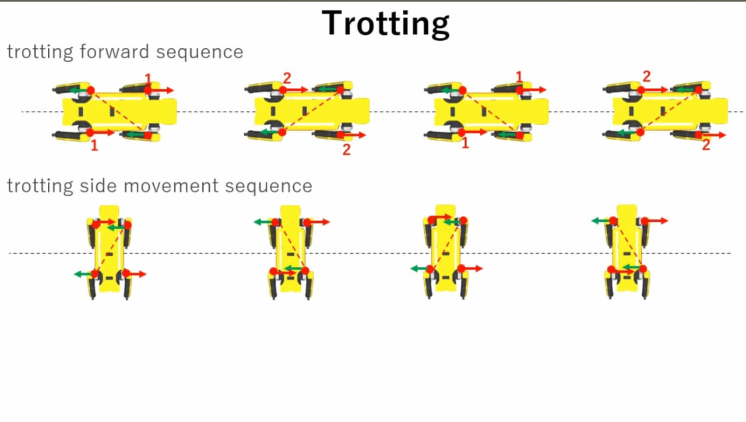

Figure – Trot Mechanism

* Gallop Gait:
  + Highest speed locomotion but requires significant power consumption
  + Battery drain rate too high for sustained operation
  + Complex control algorithms needed for stability
  + Reserved for future development after basic locomotion mastery

7.5 Gait Generation Algorithm Understanding

* Key Gait Parameters Identified:
  + Step Length: Distance covered in each stride cycle
  + Swing Height: Maximum foot elevation during swing phase
  + Stance Height: Foot position during ground contact phase

These parameters form the foundation for trajectory planning and will be implemented in the Raspberry Pi control algorithms.

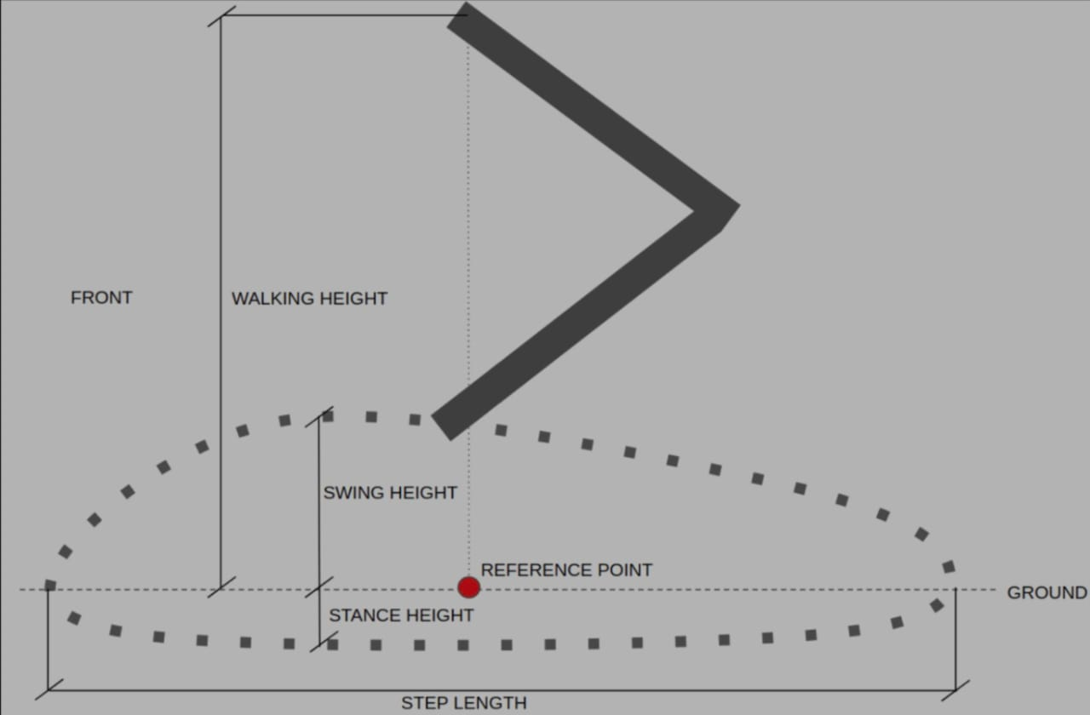

Figure – Gait Generation Mechanism

7.6 Power System Design Findings

* Power Distribution Architecture:

Custom power distribution board designed for equal power delivery to all components. Centralized power management reduces voltage drops and ensures consistent performance. Separate power rails for servo motors and electronics prevent interference

* Battery Specification - 7.4V LiPo:

7.4V selected as optimal voltage for servo motor compatibility Voltage level meets requirements for majority of high-torque servo motors LiPo chemistry provides excellent power-to-weight ratio for mobile applications Sufficient capacity for extended operation periods

* Servo Motor Specifications:

40 kg-cm torque rating determined adequate for current robot dimensions Torque capacity allows for stable locomotion and load carrying capability Scalable design permits higher torque motors if robot size increases Digital servo control ensures precise positioning and holding torque

7.7 Simulation and Visualization Findings

* URDF model conversion from SolidWorks achieved with high fidelity
* Real-time visualization provides excellent debugging and development capabilities
* Joint state publisher enables intuitive testing of kinematic calculations

# CHAPTER 8 REFERENCES

* [1] Raibert, M., Blankespoor, K., Nelson, G., & Playter, R. (2008). BigDog, the rough-terrain quadruped robot. *Proceedings of the 17th World Congress The International Federation of Automatic Control*, 10822-10825.
* [2] Wang, J., Ding, X., Gao, F., & Zhang, X. (2021). Go1: A quadruped robot for research and education. *Unitree Robotics Technical Documentation*. Retrieved from https://www.unitree.com/go1
* [3] HyperDog Robotics. (2022). HyperDog quadruped robot platform specifications. *HyperDog Technical Manual*. Retrieved from https://hyperdog.ai
* [4] Katz, B., Di Carlo, J., & Kim, S. (2019). Mini cheetah: A platform for pushing the limits of dynamic quadruped control. *2019 International Conference on Robotics and Automation (ICRA)*, 6295-6301.
* [5] Hutter, M., Gehring, C., Jud, D., Lauber, A., Bellicoso, C. D., Tsounis, V., ... & Siegwart, R. (2016). ANYmal-a highly mobile and dynamic quadrupedal robot. *2016 IEEE/RSJ International Conference on Intelligent Robots and Systems (IROS)*, 38-44.
* [6] Stanford Student Robotics. (2020). Stanford Pupper: An open source quadruped robot. Retrieved from https://stanfordstudentrobotics.org/pupper